Stirjoy WooCommerce Site – Functional Specification
1. Confirmed Tech Stack
• Email Automation: Klaviyo - roughly 50$ - 150$ per month
• Multilingual: WPML - 150$ for multilingual cms (one-time)
• Visual Builder: Elementor (TBD)
Login Wordpress:
rudyrabitbol@gmail.com
@39gm2o2&5tc

2. Platform Overview
The new Stirjoy website will be built on WordPress using WooCommerce to support subscription-based eCommerce. It will include multilingual support, recurring billing, customizable product boxes, a wholesale portal, and customer account functionality. The website will draw visual inspiration from Graza and functional inspiration from HelloFresh and Lufa Farms.
3. Customer Journey
Customers arrive via digital ads to the landing page, which is designed to guide them through a 2-step sign-up process. After sign-up, they are redirected to a personalized shopping page to customize their subscription box. Auto-checkout is triggered based on cut-off dates. The experience supports flexibility in managing orders, skipping, and cancellation through a customer account dashboard.
4. Front-End Features
4.1 Landing Page → here’s a canva for the style, key info, and features we like. Needs some work, but gives the energy and overall direction.
• Large photo with sign-up button + text
• Menu preview (4 products)
Benefits section (what’s in each meal)
• How it works (icons + text)
• Benefits carousel (horizontal scroll)
• Press mentions and customer reviews
• FAQ section
Our mission section
Social media posts section
Bottom of page menu

4.2 Sign-Up Flow
• Step 1: Basic info (First Name, Last Name, Email, Phone, Password)
• Step 2: Delivery address (Google API) + Credit card info for payment (Payment Processor Global Payment)
• Visual celebration upon completion and redirect to shopping page to customize their first box
4.3 Shopping & Checkout Page
• Default box shown at top (or bottom) ("basket" view) → similar to Planthood’s layout, but our basket would have more info like product name and price (see image below)
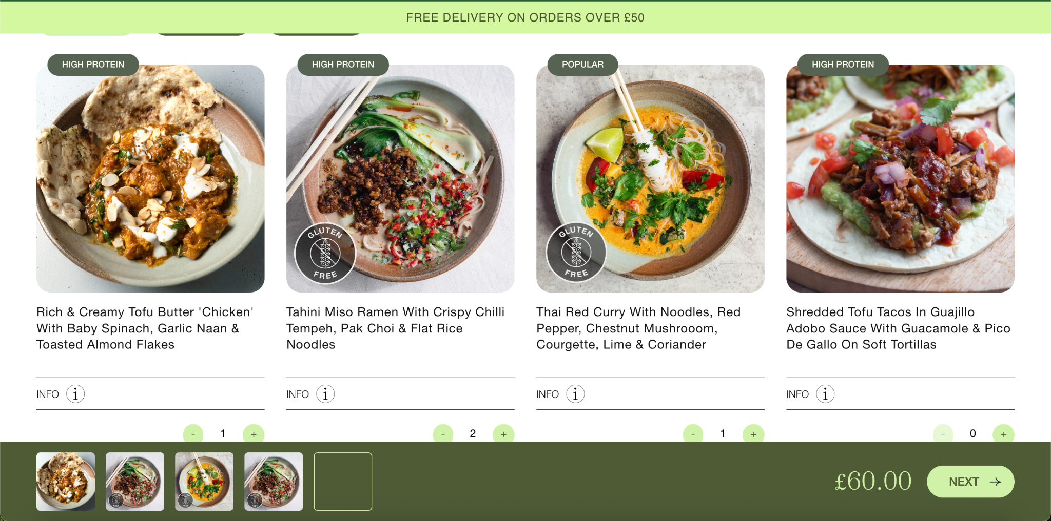
• Add/remove recipes with "+" and "-" buttons
• Milestone bar (e.g., free shipping at $75) → ideally this would be clean an efficient with a few clear milestones (free shipping after 75$, gift after 125$, etc. We will test many different things here, so it needs to be relatively easy to edit.
• Product cards: dual images (on hover), product name, cook time, protein amount
4.4 Customer Account
• Google login, Credit Card Pay, and password login options
• Calendar interface to skip, reschedule, or cancel boxes
• Edit personal info and subscription settings
• Track past and upcoming deliveries with tracking links --??? Tracking # TBC → Ideally this feature is updated automatically by our 3PL and delivery partner when they create the shipping label. The tracking link can re-direct to another website (canada Post, Obibox, etc)
• Retention flow for cancellation (includes "Why are you cancelling?" questionnaire) → this needs to be linked to account settings, as we will offer button options throughout the cancellation flow leading to things like “skip a box”, “change your delivery address”, or “contact us”.

4.5 About us page
• Text + photos + video option

4.6 Map of retailers
• Map of retailers similar to this: ​​https://dunord.club/pages/ou-nous-trouver

4.7 Contact us
• Basic fields (name, email, text) + dropdown for reason of email to send to the appropriate email address (CS, sales, hr, pr)

4.8 Terms and conditions
• Terms and conditions, Privacy policy, Returns policy

5. Wholesale Portal
• Separate sign-up with business-specific fields // No Account Approval – Fill up form. (business name, contact name, contact email). Customer address, credit card, and phone number should only be added at checkout of their first order. They should also have the option to save multiple locations for delivery
• Unique store with bundle products only (e.g., 14-packs)
• Minimum order value of $100, free shipping over $300 (otherwise flat shipping at 15$)
• Dedicated FAQ and visible contact information for B2B support
6. Backend Features
• Recurring billing engine (monthly default, weekly and bi-weekly optional)
• Admin tool to build and edit default boxes for each delivery period
• Ability to configure multiple box types (e.g., 6 meals, 8 meals, vegan) → this should also include the option to have different boxes for different delivery regions (Western Canada, Eastern Canada, determined by the user’s delivery address)
• Full visibility into user history and actions (logins, changes, orders, emails) → these events should be actionable via automations (create CS ticket if X action is taken by customer, send automated email if user hasn’t logged in for 60 days, etc)
• Admin controls to act on customer accounts (edit, cancel, refund, etc.)
• Admin notes on customer profiles
• Dashboard with metrics for chosen period: active users, new users, orders, revenue, AOV, churn, take rate (% of active users who got an order in the last 30 days)
• Exportable data and search/filter capabilities → everything except credit cards should be searchable and exportable here to create custom reports for our different teams (accounting, IT, marketing, etc). A concrete example of one report we should be able to create is a “Tax” report where the accountant can export all taxes collected for a given period, split by tax type (TPS, TVQ, etc). Another example would be a marketing list where all active user emails are exported to create a custom Facebook ads campaign or lookalike audience.
• Coupon code creator (similar to Shopify’s coupon code generator) with the ability to set expiration date, amount or % off, free item added (customizable based on available products).
• Referral program (a customizable coupon code generated for all users that they can gift to friends to give them X off their first box. Each time a referral code is successfully used, the referrer gets an X credit to their account).

7. Email Automation
• Welcome email (triggered post sign-up)
• Reminder email 3 days before box processing
Second reminder day of if no login
• Confirmation emails for orders and payments
• Shipping notification with trackingBus
• Cancellation confirmation email
- Failed payment recovery email flow (immediate send + 1 day after send)
- Incomplete sign up email flow (almost there after 1 hour, benefits email after 1 day, special offer after 6 days)
- “what you’re missing while you’re away” flow for customers who skipped a given month.
• All campaigns and flows powered by Klaviyo
8. Not in Scope
• A/B testing plugins
• Real-time chat functionality
• Front-end sustainability metric widgets

Business Logic:
Une commande peut être personnalisée, Skip ou devance, annule ou déplace
Une commande: La date de creation de commande + date d’expedition
Si une commande est cree apres 23h45 - la date d'expédition sera day + 1
Le cutoff date est déterminé par la date d’inscription du client.
Ex: Le client s’inscrit le 10 Octobre 2025, à 16h.
Il a jusqu'à minuit pour personnaliser sa boite, sinon boîte régulière.
A minuit - la commande ne peut plus être annule - la commande est paye (paiement pris au complet)
Prochain cutoff le 10 Novembre à Minuit.
Le client a jusqu'à minuit pour personnaliser ou skip la commande ou annuler.
Thank you Page - for orders & registration
L’usager peut déplacer la date de livraison à une autre semaine le 10 avant minuit.
Flow régulier d’un client:
- Création du compte (10 octobre, 16h)
- Personnalisation de la boîte au même moment (16h01)
- Cutoff à minuit: la commande est officiellement confirmée (plus possible de personnaliser) et payée
- Livraison de la commande dans les 2-5 jours ouvrables suivant la cutoff date.
- 7 novembre: une nouvelle commande brouillon est activée et pré-peuplée selon le menu du mois
- 7 novembre: le client reçoit un courriel 3 jours avant la commande lui disant qu’il peut aller personnaliser sa boîte.
- 10 novembre: si le client n’a pas log in, il reçoit un courriel de rappel lui disant que le cutoff est ce soir à minuit. Le client va donc sur son compte et personnaliser sa boîte.
- 10 novembre, 9h45 pm: le client décide de changer sa cutoff date pour recevoir sa commande plus tard (il vient de se souvenir qu’il ne sera pas là pour recevoir la boîte cette semaine). Il pousse la cutoff date au 17 novembre (le panier reste le même selon ses personnalisations, c’est juste la date de livraison qui est changée).
- 17 novembre, minuit: cutoff time, la commande est confirmée est payée.
- 7 décembre: la boîte régulière mensuelle du client est activée
- etc

